**MANUAL STARTUP SYSTEM**

**Setup System**

**Installation Requirement**

1. **Node.js**
2. **MySQL**
3. **METAMASK**
4. **Connect METAMASK to Polygon Mumbai Testnet**
5. **Smart Contract Ownership**

**Node.js**

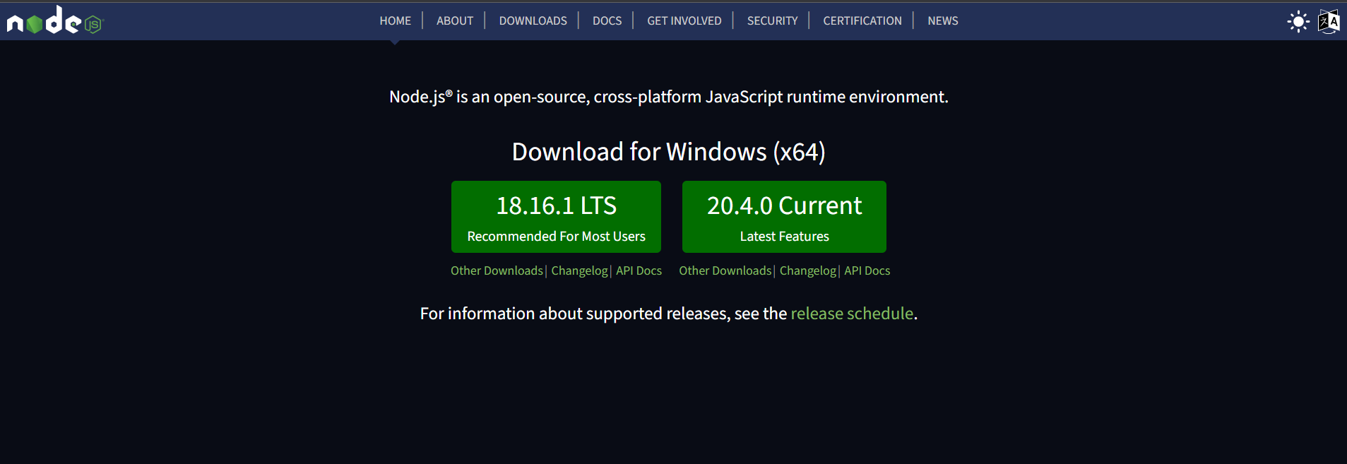

**Install node.js in your operating system**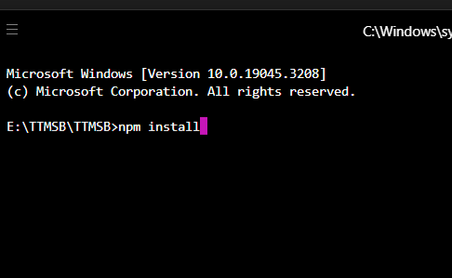

**Run in powershell npm install on the system directory to install all dependency**

**MySQL**

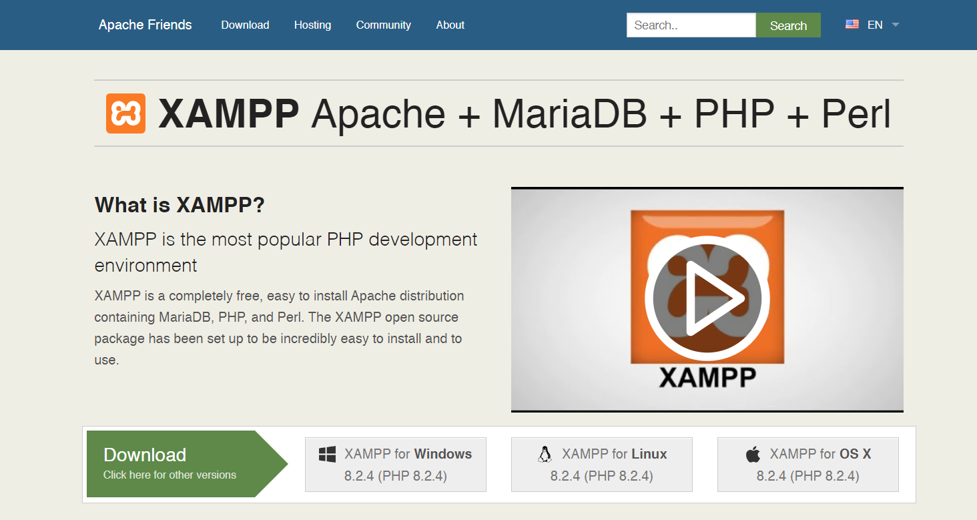

**Install XAMPP for PHPMyAdmin MySQL**

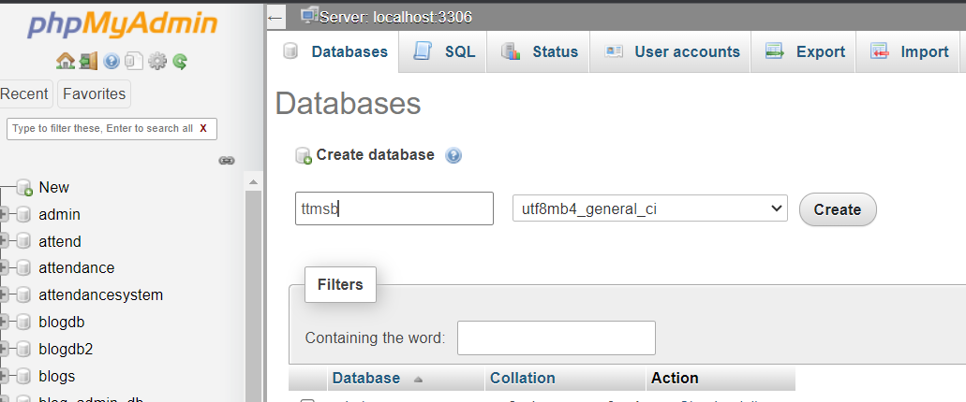

**Create database ttmsb**

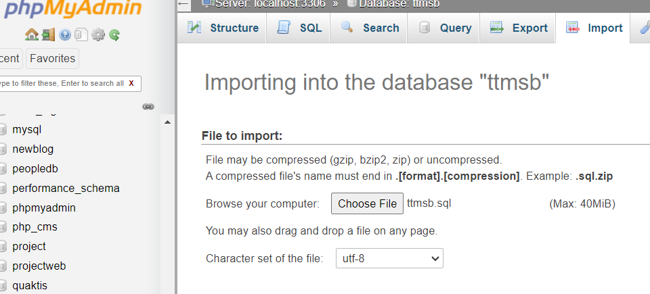

**Import database ttmsb**

**METAMASK**

**Setup METAMASK**

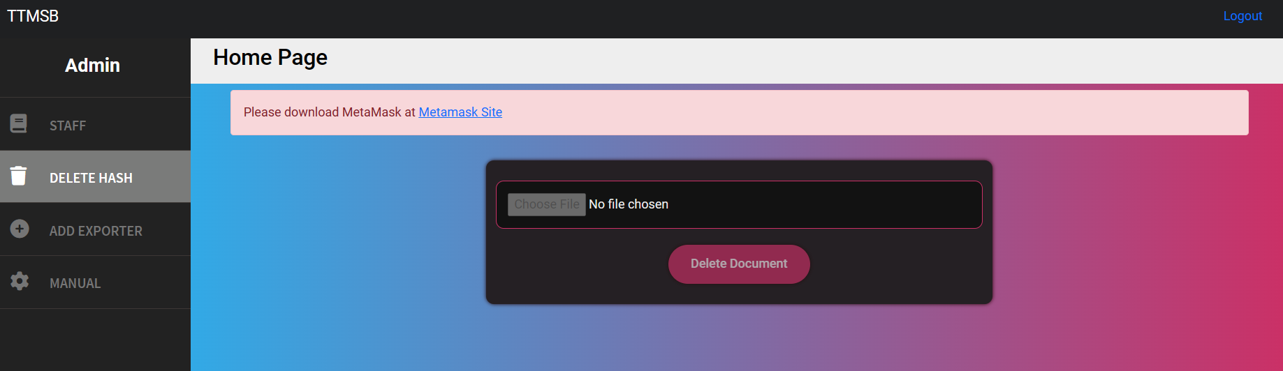

**User require to install metamask to use the system**

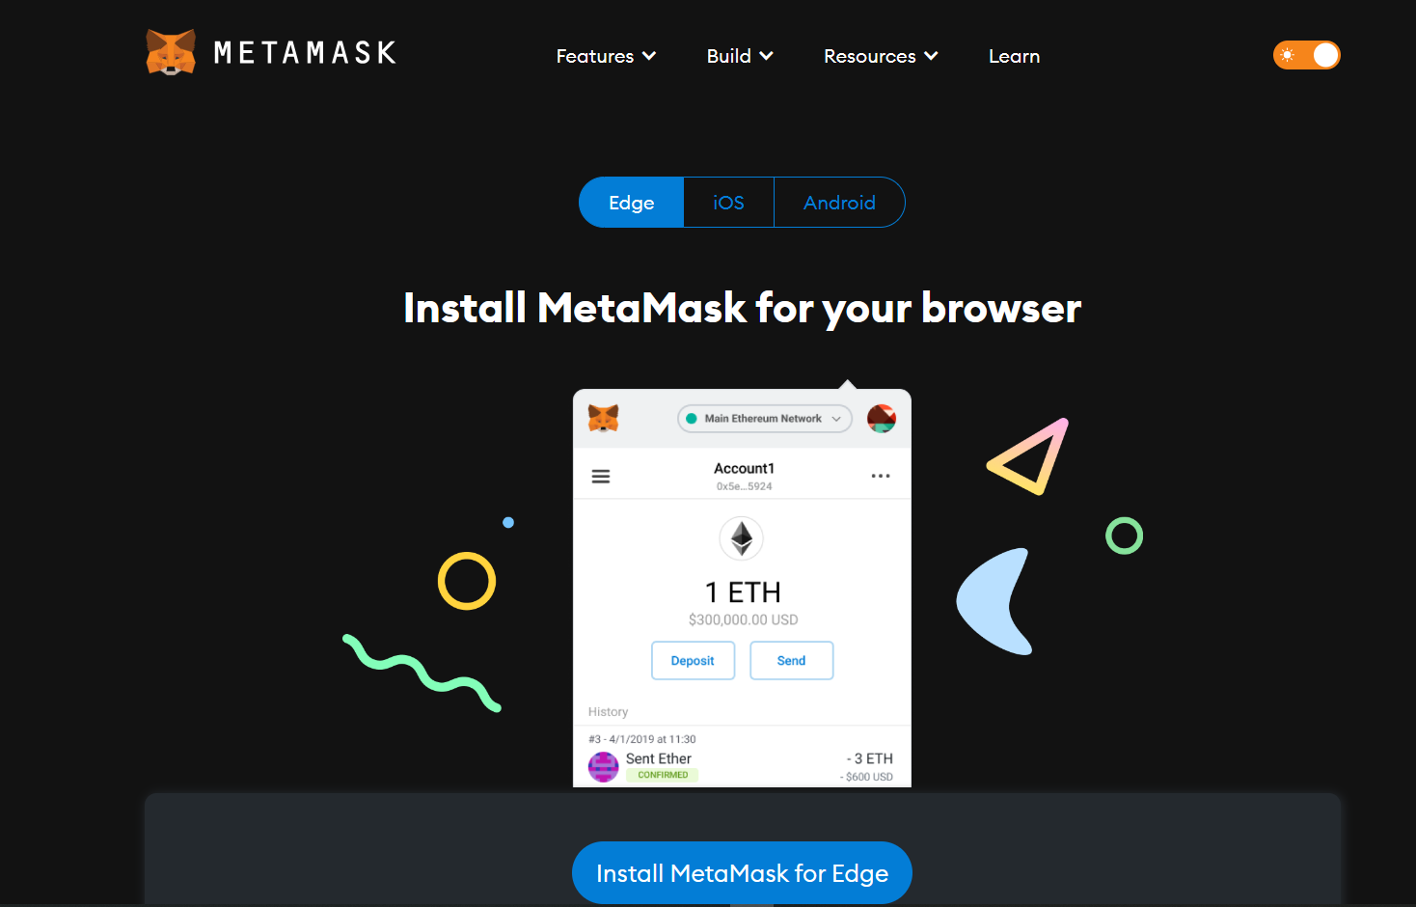

**Install extension in your browser**

**Connect METAMASK to MUMBAI TESTNET**

**enable the Mumbai testnet for METAMASK (INSTALL METAMASK FIRST)**

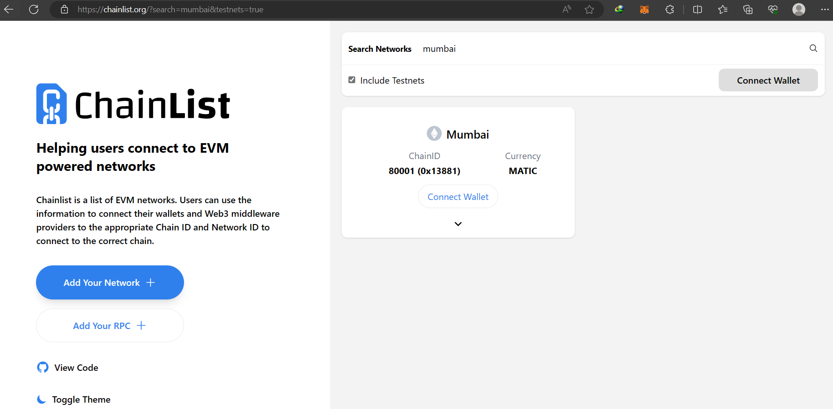

**Go to chainlist.org and search MUMBAI and connect Wallet**

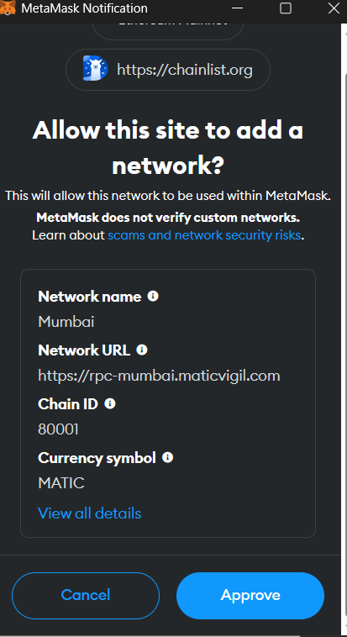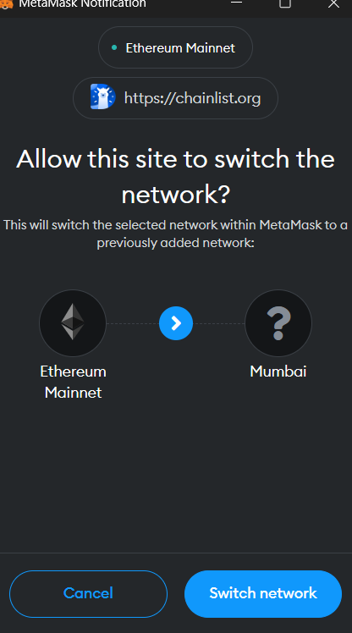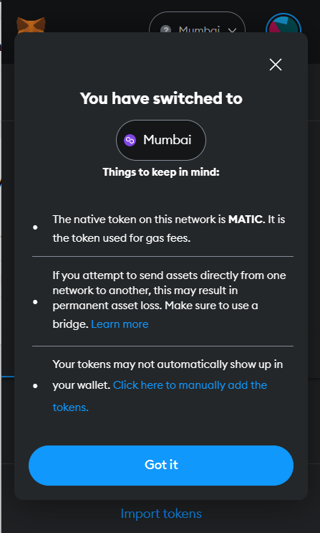

**Approve and switch Network to Polygon Mumbai Testnet**

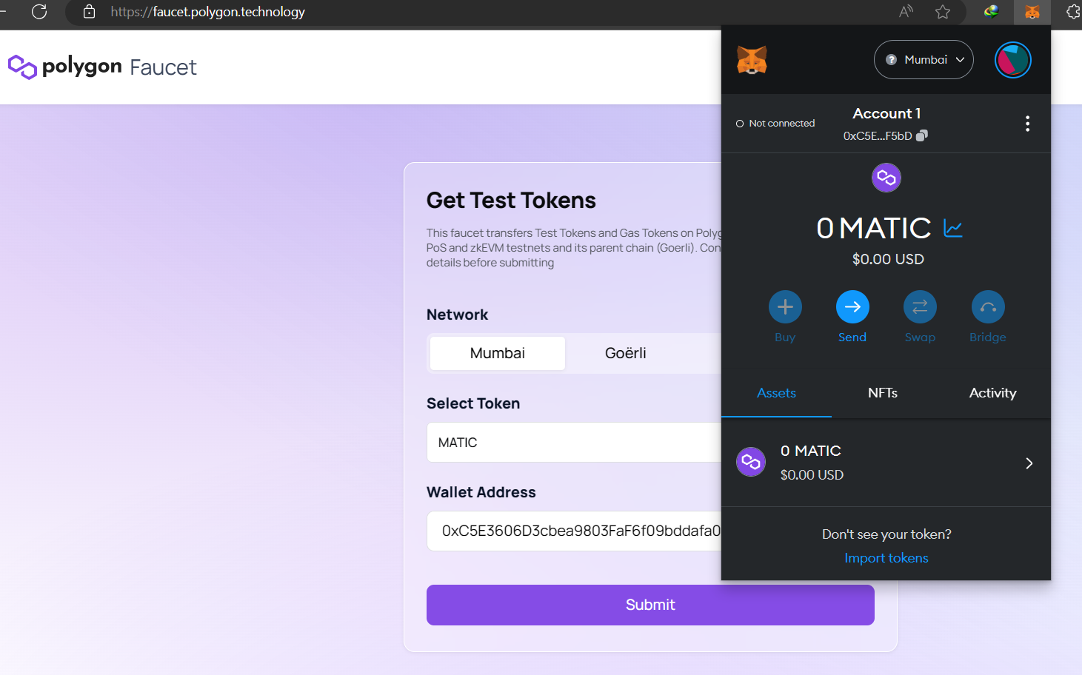

**Go to faucet.polygon.technology**

**Get test token select Mumbai**

**Copy the Wallet ID (Circle in the figure)**

**Paste in the form and submit**

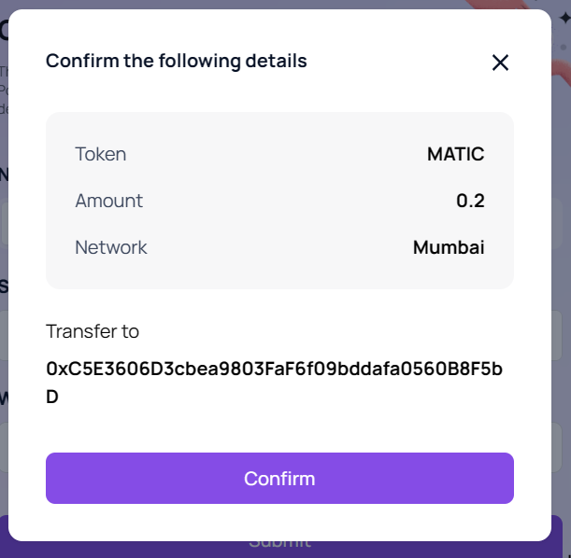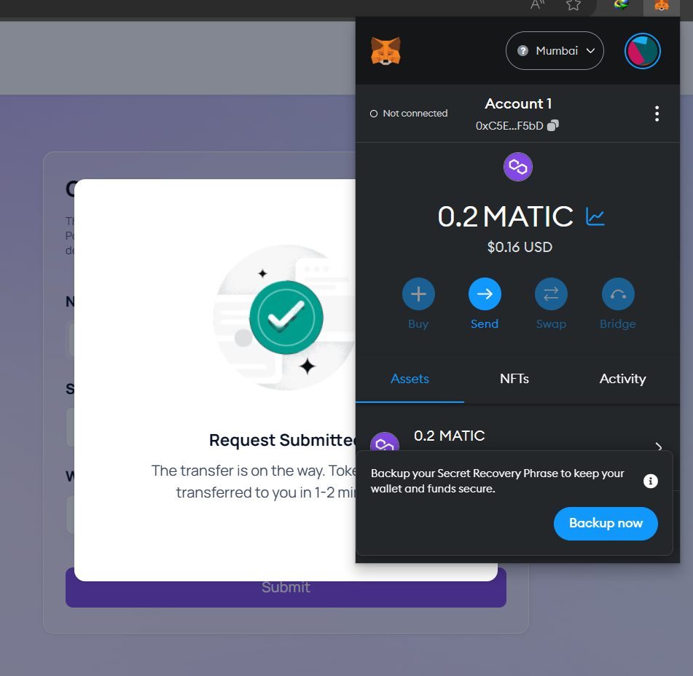

**Confirm and wait for 5 minute to get the testnet token**

**SMART CONTRACT OWNERSHIP**

**To enable ownership for Blockchain Smart Contract**

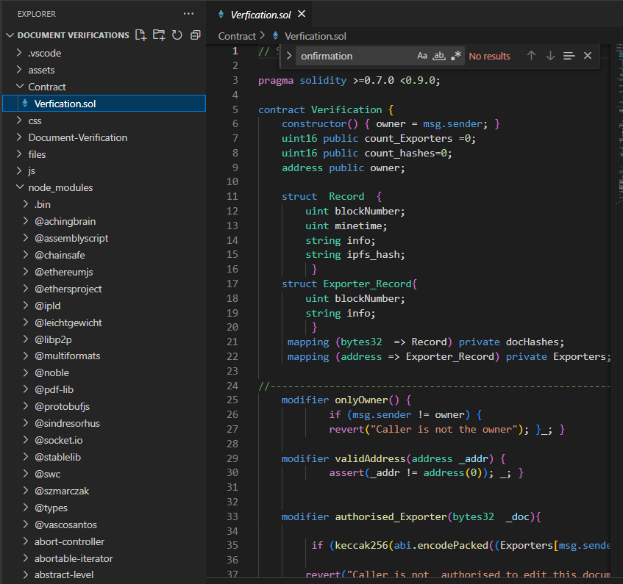

**Find Verification.sol in Contract folder and copy the code**

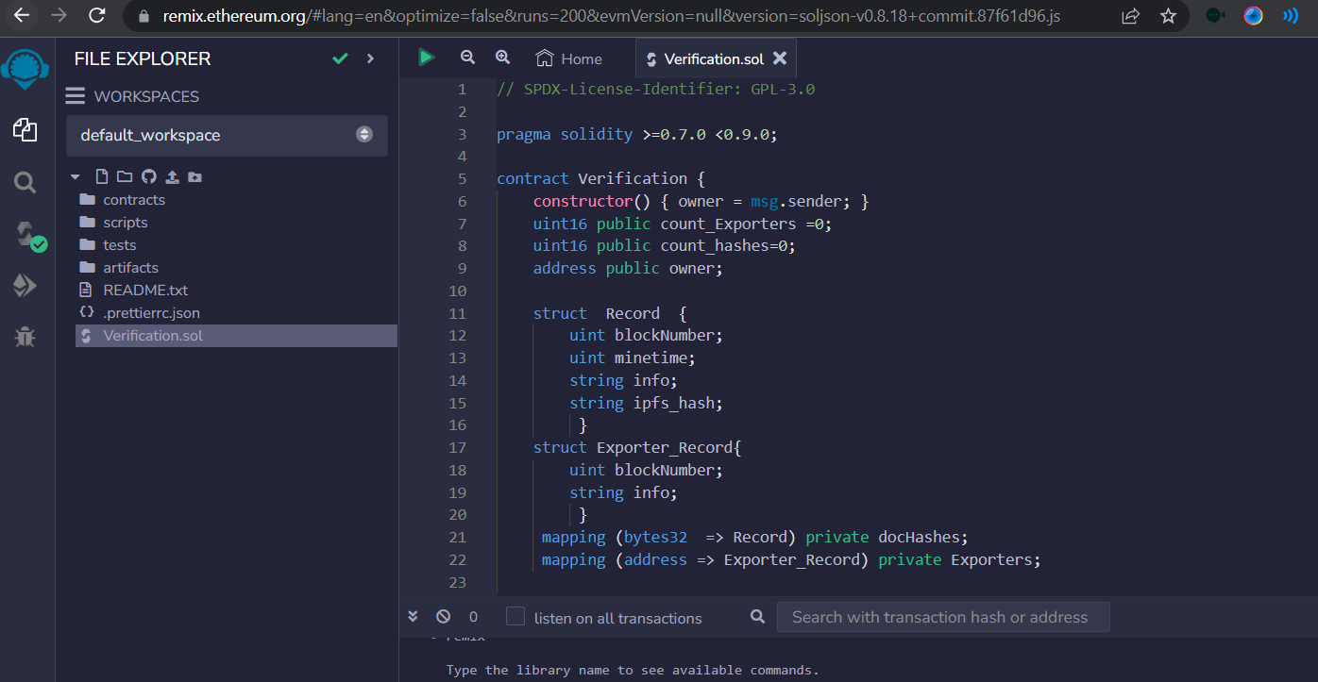

**Create new file and paste the smart contract code**

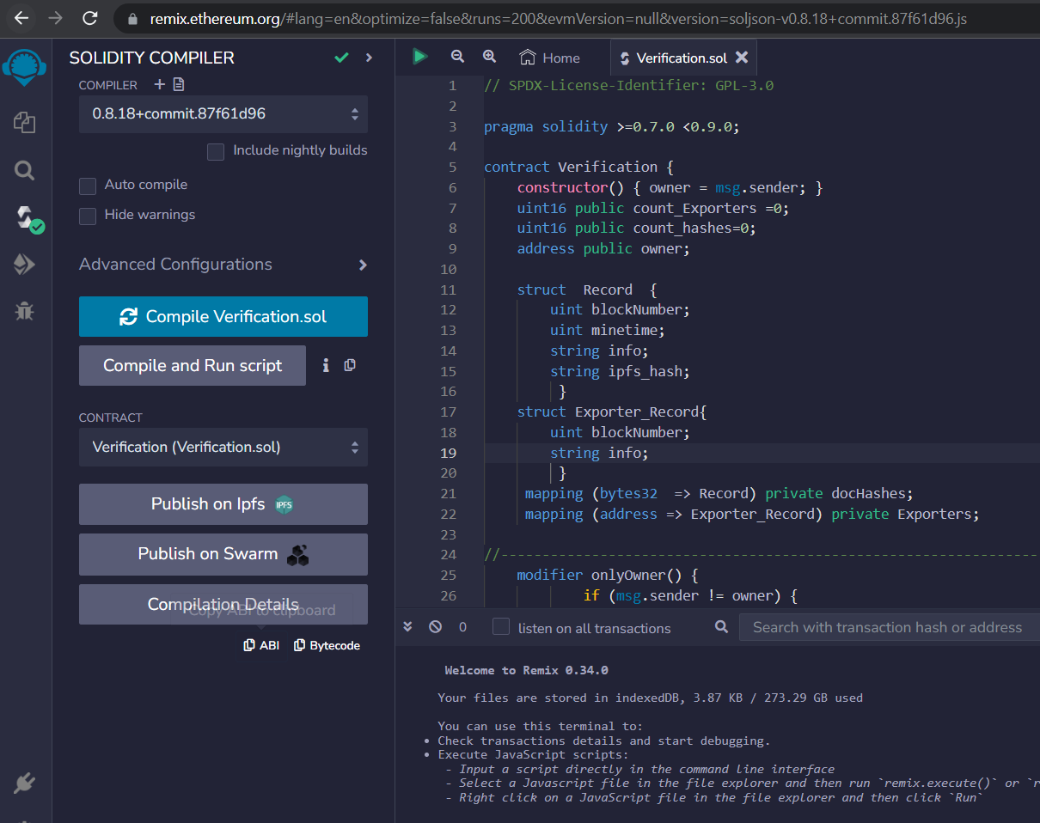

**Compile the smart contract code**

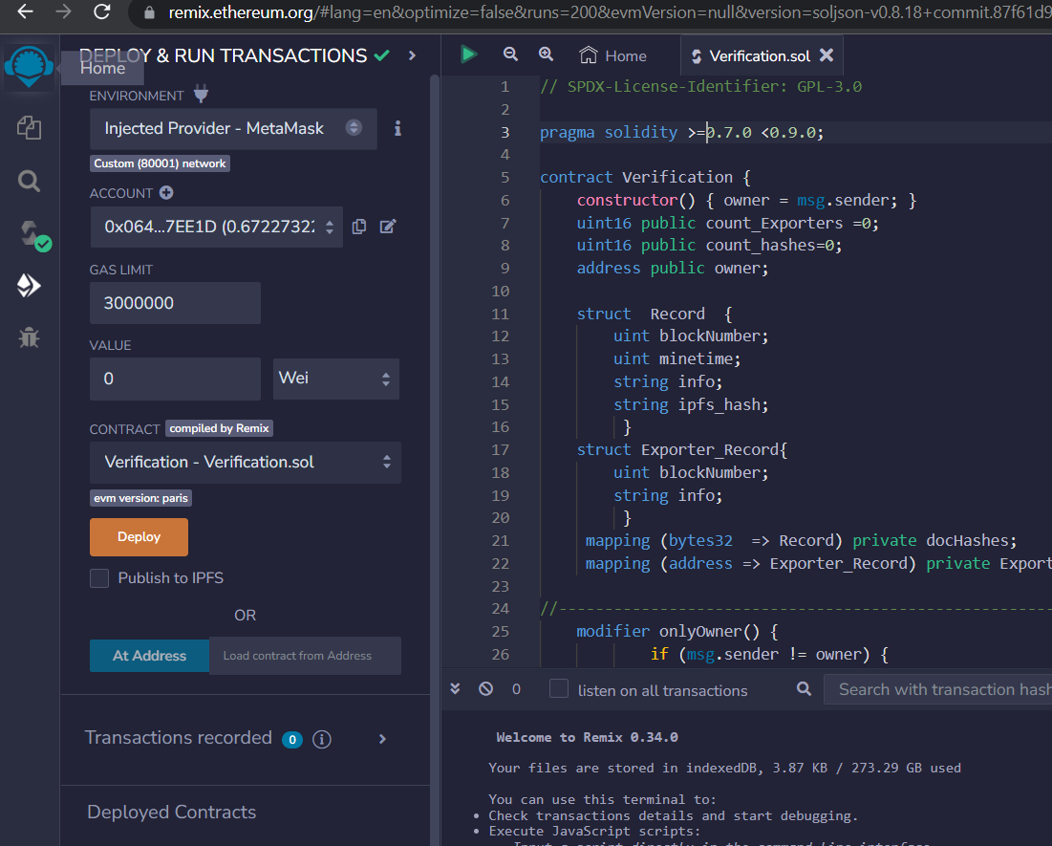

**Go to Deploy and Run Transaction**

**Select in Environment = Injected Provider – Metamask**

**Click Deploy**

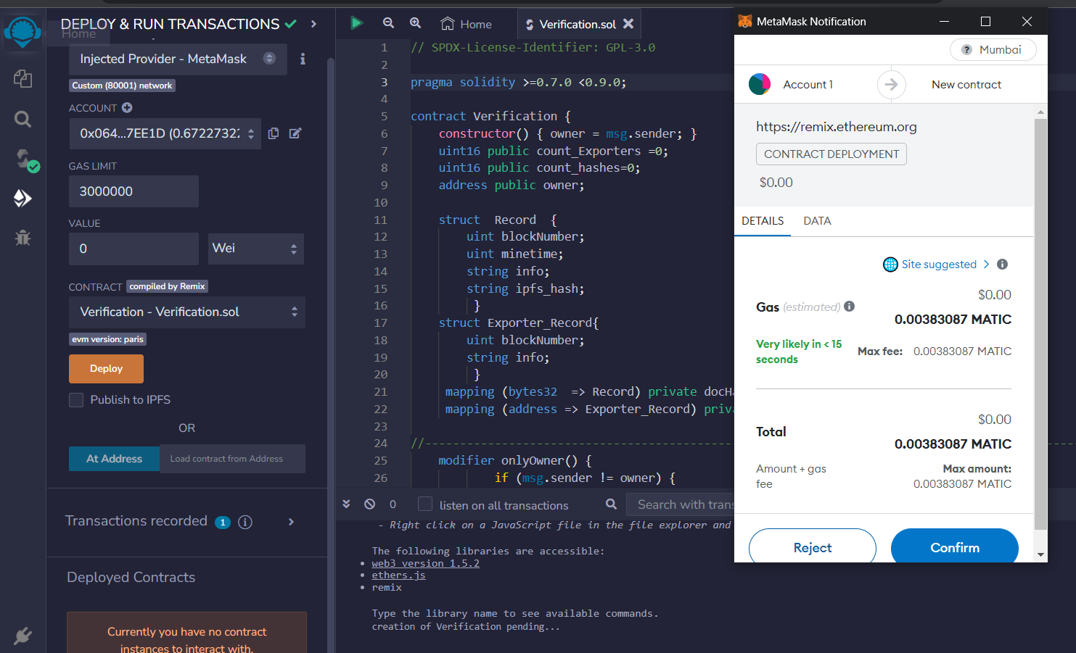

**Confirm the transaction**

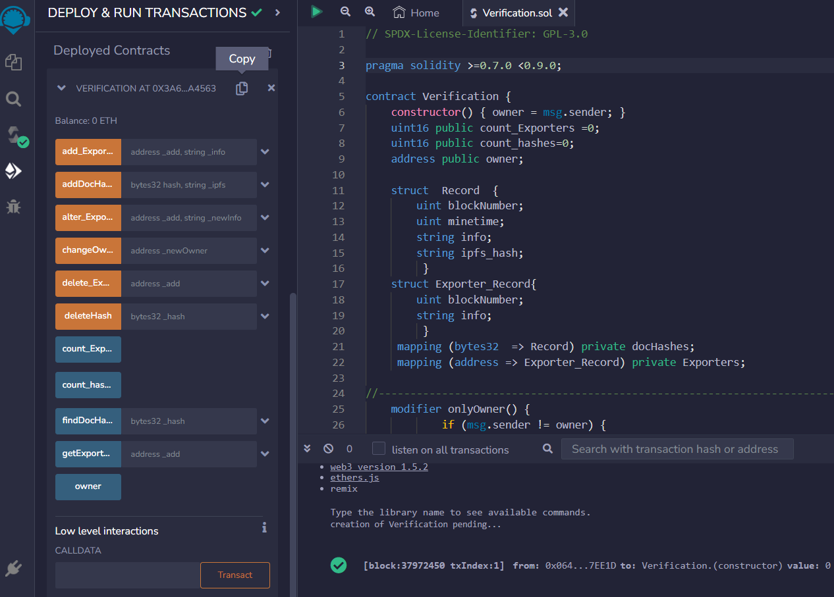

**Click Copy the smart contract address**

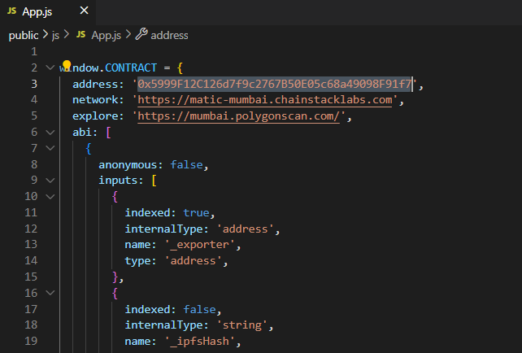

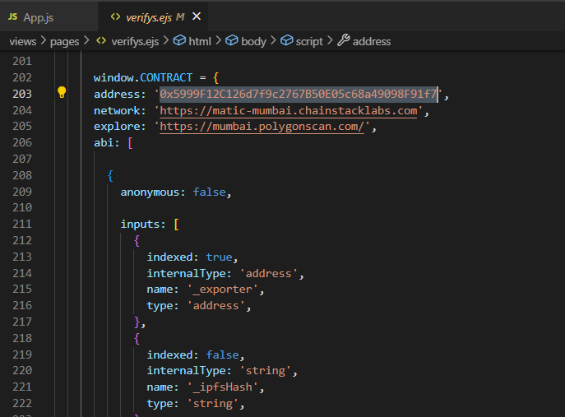

**Paste the smart contract address in App.js and verify.ejs**